**The Problem Statement**

Jan's wholesale and Retail is a small grocery store in Papine. The supermarket's management is dissatisfied with the service they provide to their customers, particularly on weekends and at the end of the month when the store becomes crowded. The lines at the supermarket are extremely long because clerks must manually write up the invoices before the customer pays at the cashier. Currently, the cash register is only used to collect money for payment. It does not keep track of what is checked out so that the inventory can be updated.

The management has made the decision to computerize their system in order to improve the customer experience and reduce the lines. They expect the system to improve their internal procedures as well.

**Dashboard**

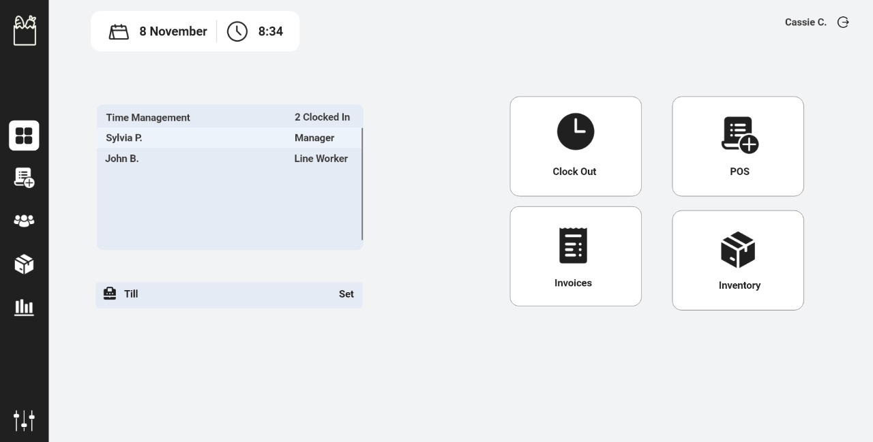

The dashboard page was designed to display various system functions. The control panel, which is shown to the far left of the dashboard, contains a list of the different pages. The control panel allows the user to navigate from one page to another or vice versa. The dashboard also displays the user's clock in time, their names, the list of the user that has been clocked, and the field of work with which they are associated. The system also includes functional buttons such as Clock out, which allows employees to clock out when their shift is over, POS, Invoices, and Inventory. The page also displays the date and time, as well as a Log out Label & Button that contains the user's name and allows them to log out of the system.

**Point of Sale Screen**

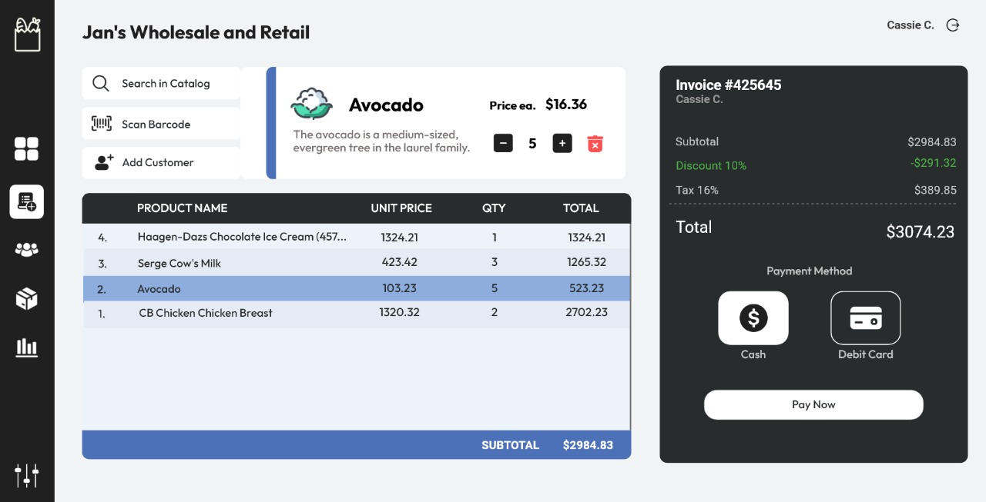

A POS system, also known as a point-of-sale system, is a combination of hardware, software, and payment processing services that businesses use to accept payments from customers in person or online. Modern POS systems generate reports, help manage inventory, and allow employees to clock in and out, among other things, in addition to completing transactions, printing receipts, and tracking sales. The POS system enables the user to search the catalog, scan barcodes, and add customers to the system. When a product item is selected, the system displays its desperation and price. The user has the authority to change the quantity of the items or delete them if they are no longer required. The point of sale page will display the produce name, unit price, quantity, and total of each acuminated price for each item. The system will then generate an invoice that includes the subtotal, tax, and, if applicable, a discount. The point of sale page will also allow the user to select the appropriate payment method for the customer.

**Customer Management**

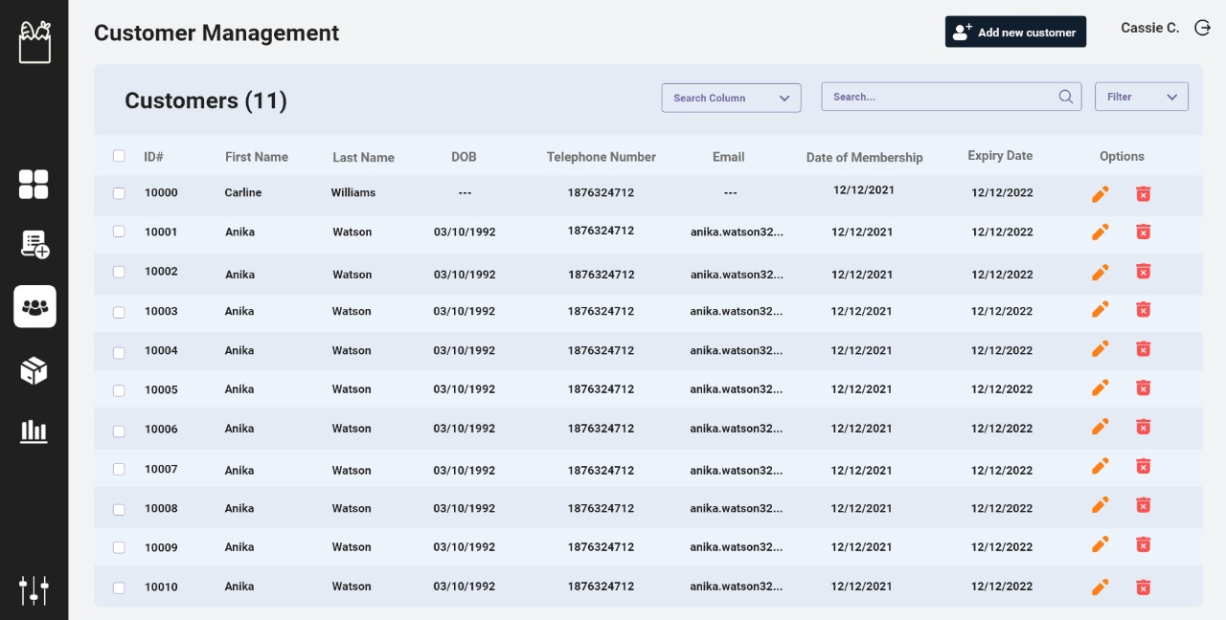

Utilizing the database that was created, this will keep track or rather keep the customers that has membership with the company up to date. The user can view a list of first and last names, dates of birth, phone numbers, email addresses, the date of the customer's membership, and when it will expire. The user has the ability to edit customer information as well as delete information when it is no longer guaranteed. The system also allows them to easily search for the customer they are planning to look for and access the information required. The management allows the general public to shop in the store, but members receive a ten percent (10%) discount off the total before tax (15%) is added.

**Inventory Management**

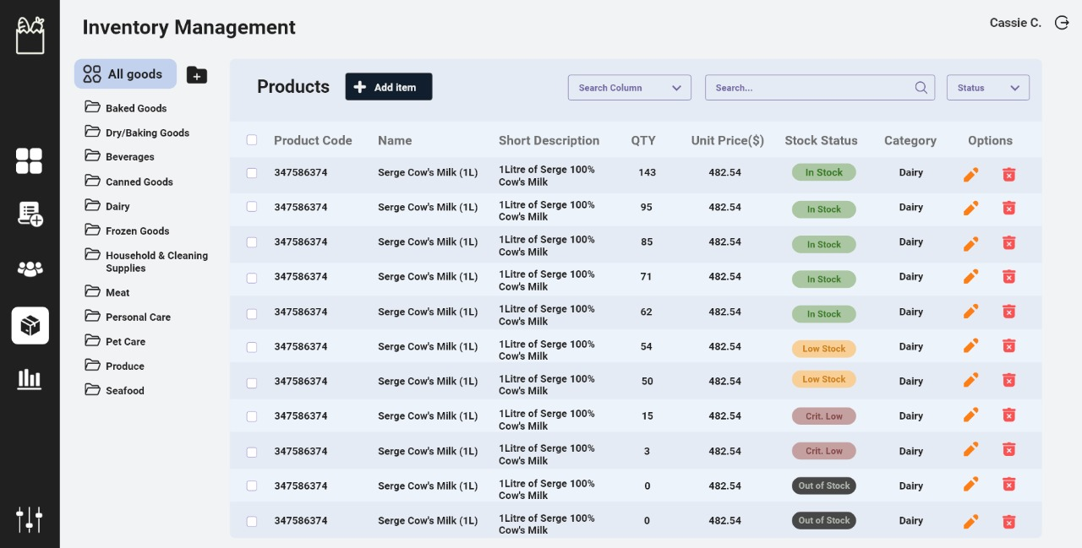

The inventory management system is used by the inventory management to view the stock of specific products in the warehouse and determine when to replenish the supply from their suppliers. The system would also assist inventory operators in updating product information, deleting product information, and inserting new products and their information. The inventory management displays the product code of the items, as well as the name of the inventory items. The system also provides a brief description of the product as well as the quantity of the product, which automatically updates the stock status and informs the user whether the product is in stock, low stock, or out of stock. The system displays the product's price and allows the user to edit the information on the system; additionally, the user can delete an item if it is no longer required. The system displays the item's category, whether it is dairy, canned, or beverage excreta, making it easier for the user to locate the item.

**Sacles Repots**

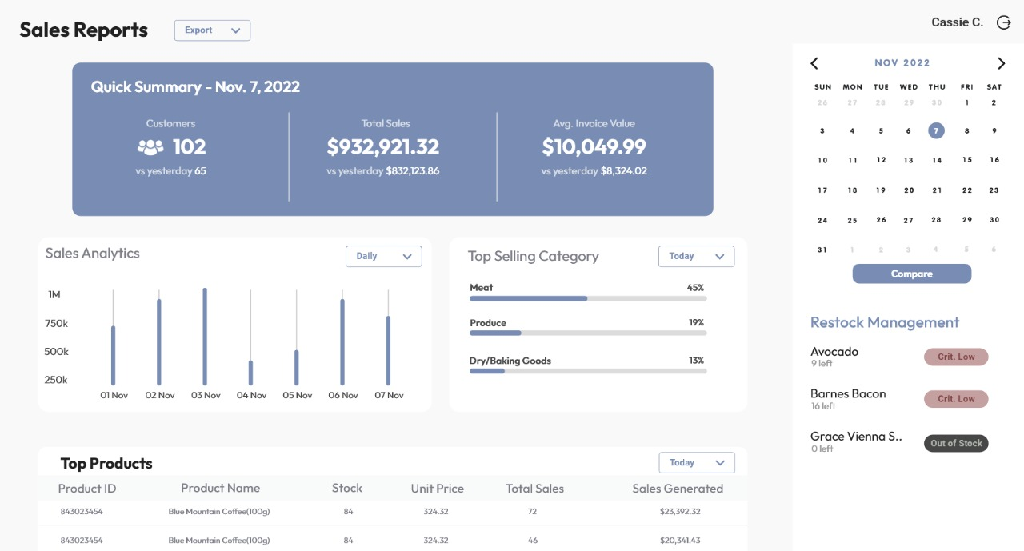

Accounting staff are able print reports on various aspects of the system using the sale report. They can retrieve data on a specific product between specific time periods. This should help them analyze customer demand for the product to determine whether it should be restocked or at what rate it should be restocked. When a sales report is selected, the system can display a quick summary of the days. The quick summary allows the user to view the number of customers who actively purchased an item and compare it to the previous day's performance. The quick summary also summarizes the total sales made for the day and evaluates them. The system also demonstrates a total of the invoice value and compares the company's progress. The sales report displays the most frequently purchased category for the company; it compares each category and displays the best seller to the least interested category based on customer purchases and sales generated for the item. The system will automatically generate a restock management report, which will inform the user of items that are critically low in stock or out of stock.